SENDCAA HEAD START
BIRTH TO FIVE
ANNUAL REPORT
2019-2020

SENDCAA Head Start Birth to Five Mission Statement: Creating a community of learners through nurturing children and engaging families.
This report is prepared to comply with the Head Start Reauthorization Act of 2007. This act states:

Each Head Start agency shall make available to the public a report published at least once in each fiscal year that discloses the following information from the most recently concluded fiscal year, except that reporting such information shall not reveal personally identifiable information about an individual child or parent:

(A) The total amount of public and private funds received and the amount from each source.

(B) An explanation of budgetary expenditures and proposed budget for the fiscal year.

(C) The total number of children and families served, the average monthly enrollment (as a percentage of funded enrollment), and the percentage of eligible children served.

(D) The results of the most recent review by the Secretary and the financial audit.

(E) The percentage of enrolled children that received medical and dental exams.

(F) Information about parent involvement activities.

(G) The agency's efforts to prepare children for kindergarten.

(H) Any other information required by the Secretary.

SENDCAA Head Start Birth to Five Vision Statement: Building on a cornerstone of success that inspires all children and families to reach their full potential.
About Our Program
Head Start & Early Head Start programs exist to provide comprehensive early childhood education, health, nutrition, and parent involvement services to low-income children and their families. Our program provides services to a total of 357 children from birth to 5 years of age. Our Early Head Start program also has a Pregnant Moms Program, which reserves 4 slots to pregnant women. This program provides support for emotional well-being, nurturing and responsive caregiving, and father engagement during pregnancy and beyond.
The SENDCAA (SouthEastern North Dakota Community Action Agency) Head Start Birth to Five Program provides these comprehensive services to children and their families at our various locations across North Dakota. We have sites located in Lisbon, Wahpeton, Fargo, and West Fargo. Our administrative team consists of the following: Project Director, Assistant Director, ERSEA/Family Partnerships Coordinator, Health & Nutrition Coordinator, Education Coordinators, Administrator of Operations, and Administrative Assistant. This team oversees and supports the overall direction of the program.
We have staff who provide direct services to children in the classroom- teachers, paraprofessionals, teacher assistants, and behavior support staff. With support of program Education Coordinators, Mental Health/Disability Coordinator, and our coaching team, these staff focus on providing services in the areas of Social-Emotional, Cognitive, Physical, Mathematics, Literacy, and Language. Our program implements the Creative Curriculum and Conscious Discipline in the classrooms.
The SENDCAA Head Start Birth to Five Program also provides services to families in the areas of health, nutrition, and family involvement. Family Support Coordinators (Health Coordinators, Family Advocates) support families in maintaining overall child health & wellness, providing a variety of parent education and resources, and encouraging routine family participation. We have wonderful cooks who meet the nutritional needs of the children enrolled in our program.

Expenditures and proposed budget
2019-2020 grant year budget:
Grant Revenue | Federal | State
US Department of Health & Human Services | 3,690,064
USDA |  | $147,535
In-Kind | $880,021
Total Program Revenues | $4,570,085 | $147,535
Program Expenses
Salary & Wages | $2,352,933 | $61,421
Fringe | $617,166 | $18,353
Contracted Services | $42,072
Supplies | $86,724
Travel | $46,070
Space Costs/Rentals | $368,304
Other Direct Costs | $146,608 | $67,761
Insurance | $30,187
In-Kind | $880,021
Total Program Expenses | $4,570,085 | $147,535

Proposed budget 2020-2021:
Grant Revenue | Federal | State
US Department of Health & Human Services | $3,656,581
USDA |  | $209,754
In-Kind | $914,145
Total Program Revenues | $4,570,726 | $209,754
Program Expenses
Salary & Wages | $2,378,706 | $102,270
Fringe | $621,643 | $33,442
Contracted Services | $42,072
Supplies | $30,712
Travel | $44,920
Space Costs/Rentals | $339,699
Other Direct Costs | $166,192 | $74,042
Insurance | $32,637
In-Kind | $914,145
Total Program Expenses | $4,570,726 | $209,754

Review by the Secretary
Currently, there are no scheduled Federal Reviews. SENDCAA Head Start had a Focus Area 1 Review in April of 2019. There were no findings on this review.
Financial Audit
During the financial audit, there was a finding in the internal control policy. Our program had one other finding due to a misinterpretation on the 429A report. Both findings were reviewed and our program created a corrective action plan to move forward and address the areas of concern.

Total Number of Children served 2019-2020
Head Start | 369
Early Head Start | 74
Average Monthly Enrollment (as a % of funded enrollments)
Head Start | 100 %
Early Head Start | 100 %
Total Number of Families served 2019-2020
Head Start | 331
Early Head Start | 62
Meet Our Children & families

Family Engagement Services
Family Services staff worked hard to engage our families in the program through parenting classes, family goal setting, and day-to-day communication.
Family Goals
Our staff partnered with community members to offer education related to common goal areas such as continuing parent education, job training and family finances. We also connected families with evidence based parenting classes available in our community through NDSU extension and Sanford Health. Our program had just kicked off our Conscious Discipline parenting class in March when it was postponed due to the pandemic hitting our community.
Parent Committee
In addition to the workshops and parenting classes our program provided Parent Committee events that gave parents the opportunity to meet with other parents at their site and provide positive input and feedback on the day to day operation of their site. These meetings concluded with an engaging activity in the classroom with their child. The focus areas for these Parent Committees within the classroom range from Conscious Discipline, mathematics, and literacy activities.
Resources
We continued to work with families throughout the year to assess and meet the needs of our families that created potential barriers to be successful in school. When the pandemic hit, these efforts became even more necessary to the welfare of our families. We worked to ensure families had access to free community meal opportunities and food bags to pick up each week from Great Plains Food bank along with distributing additional family education.
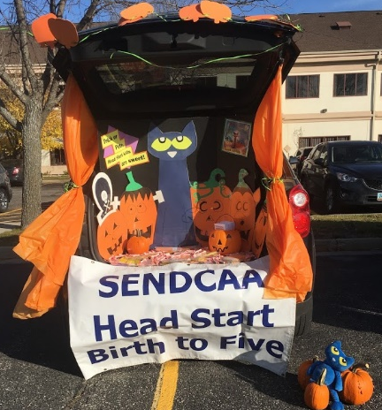
(Above) Staff recruited in the Fargo community at a Trunk or Treat event October 2019 and families enjoyed the Winter Parent committee event at Wahpeton in December 2019.

Services received/referrals
Emergency or Crisis Intervention (food, clothing, shelter) | 344
Housing Assistance | 18
Asset Building Services | 17
Mental Health Services | 23
Substance Prevention | 13
English as a Second Language | 32
Adult Education | 28

Policy Council
The Head Start Policy Council makes decisions about the overall direction of the program in Cass, Richland, Sargent, and Ransom counties. The council is made up of elected parent representatives, past parents, and individuals from community agencies. Our program was fortunate to have very active and engaged Policy Council members throughout the 2019-2020 year. We also had community representatives attend regularly from the Anne Carlson Autism Center and the Evenstart Program.
Health Services
Dental
Our program prides itself on the wonderful health partnerships we have with service providers and want to highlight some of the work done for our children throughout the 2019-2020 year. We worked hard to partner with a local dentist as they kicked off their first Oral Health Case Management Grant Project in the state of North Dakota. The hope with this project was to show the many benefits of active case management, including identifying high-risk children with extensive needs early and getting them linked to specialized care. As part of this exciting project, there were a total of 235 SENDCAA Head Start Birth to Five children (in Fargo, Lisbon, and Wahpeton) who had dental exams completed and fluoride varnish administered. This resulted in an astounding $23,500 of in-kind for our program. Dental education with parents and children was completed in the classrooms in December (as part of the Oral Health Case Management Project).
Local dentistry, Apple Tree Dental, transported their machines to our Central Head Start location to complete comprehensive dental exams, x-rays, cleaning and fluoride varnish for 55 kids with insurance. Apple Tree Dental returned on two other occasions with their machines to complete follow-up dental treatment and additional dental exams on-site. Our program also transported 6 children to Apple Tree Dental to complete extensive dental treatments.
Family Health Care completed dental exams and fluoride varnish for 46 children at our Early Head Start location.
A local Pediatric Dentist completed three dental treatments for two children at no cost.

Our program celebrated Dental Health Month in February by providing dental education for the children in the classrooms. Several community partners sent their dental hygienists to our sites to spread dental health awareness in classrooms. Additionally, each child received a free toothbrush and toothpaste.
Well-child & immunization
Due to a partnership with Sanford Family Medicine, 9 children had completed well child exams. Our Wahpeton Head Start Site was fortunate to work with Public Health and get well child exams and immunizations completed on-site for children with and without insurance.
Vision
One of our children received a free pair of glasses through the Fargo Lion’s Club.
Nutrition
Our program celebrated National Nutrition Month in March. In collaboration with NDSU extension, our program was able to provide 7-weeks of cooking classes that were held at our West Fargo Head Start Site. Due to the pandemic, this class shifted to be offered virtually. In January and February, Family Support Staff/Health Coordinators completed one nutrition lesson with the children through the EAT program. Each month the children learned a different lesson, prepared a simple recipe and sampled it as well. All children received a free “my plate kit”.
Mental health & disability service
Our program is responsible for monitoring the social-emotional, cognitive, and physical development of all children enrolled. Within 45 days of entry, all children were screened using the Ages and Stages Questionnaire: Social-Emotional screener. Furthermore, all children enrolled at our Early Head Start site were screened for global development using the Ages and Stages Questionnaire 3. All 3-5 year olds were screened for global development using the Brigance Screen III.
We worked hard to collaborate with all stakeholders when it came to mental health & disability services. One way we collaborated with families is by asking all parents to complete the Ages and Stages Questionnaire: Social-Emotional version. We use these parental responses, together with classroom teacher responses, to help identify children who might benefit from mental health services in the community.
Our program was very intentional about using the same screening tool that local public schools utilized, the Brigance Screens III. This was extremely helpful for our screening and referral process to integrate well with their evaluation process.
High Quality Education
Our program’s education team consisted of Teachers, Teacher Assistants, Paraprofessionals, Relief Teachers, Teacher Coach, and Education Managers. Our education team was our greatest asset in providing the highest quality of education to the children enrolled in our program throughout the 2019-2020
academic year. This team prides itself on the nurturing environments we created, the connections we shared with children enrolled, and the overall positive impact we made in the lives of so many wonderful children in our communities.
As a part of preservice training, we invited Kayla Delzer, 2019 North Dakota Teacher of the Year to share her keynote on “Reimagining Education”. Kayla passionately talked about revitalizing learning and the overall classroom environment. This training left staff with a full heart ready for the school year. The children in our program greatly benefitted because of this training.
Coaching
Our program was extremely intentional about providing coaching to our education staff. We assessed all classroom staff while using our Coaching Point System. This neutral system was created by our program to assess the individual strengths and needs of our classroom staff to ultimately determine where support was needed. Once coaching was determined as a need, our Teacher Coach utilized the Practice-Based Coaching model to work with selected individuals. Our program had two running TLC (Together Learning & Collaborating) groups.
class
The Classroom Assessment Scoring System (CLASS®) is an observation instrument that assesses the quality of teacher-child interactions in center-based preschool classrooms. CLASS® includes three domains or categories of teacher-child interactions that support children's learning and development: Emotional Support, Classroom Organization, and Instructional Support. The chart below provides a comparison to program CLASS Scores in 2018 and 2019.

CLASS Observations occurred in the fall of 2019 by program staff who were certified CLASS observers. The chart above represents our program CLASS scores from the 2018 & 2019 year. Our program had made significant gains in the area of Instructional Support. After CLASS Observations were completed, the CLASS Observer met with the classroom teachers to review their CLASS scores in comparison to national averages. At those meetings, they discussed overall strengths and areas were growth was needed, with examples on ways to improve in specific areas.
Parent involvement
Throughout the 2019-2020 year, parents participated in 2 home visits and 2 conferences (one of these being virtual). At those visits, teachers spent one on one time with the families to discuss their child’s learning and development, their individual family needs, and shared community resources.
Our program consistently invited parents into the classroom for lunch, play time, reading stories, or sharing various customs from their culture with the classroom. Our program engaged families by sending a weekly in-kind sheet home. This would include encourage activities such as reading with children at home as well as completing academic activities based on identified individual child needs.
Getting Ready for Kindergarten
Our program worked on school readiness all year long. One item to highlight was the development of the Individual School Readiness Goal (ISRG) Procedure in 2019. This unique procedure involved individualizing goals for each child served in our program. The Individual School Readiness Goal was determined with the family after reviewing the child’s individual assessment data. After a goal was determined, throughout the year teachers supported at home learning by providing activities to families that promoted skills in the area of their ISRG. At each visit, teachers and families reflected on the ISRG and determined if that specific goal had been accomplished or if that goal was still in progress.
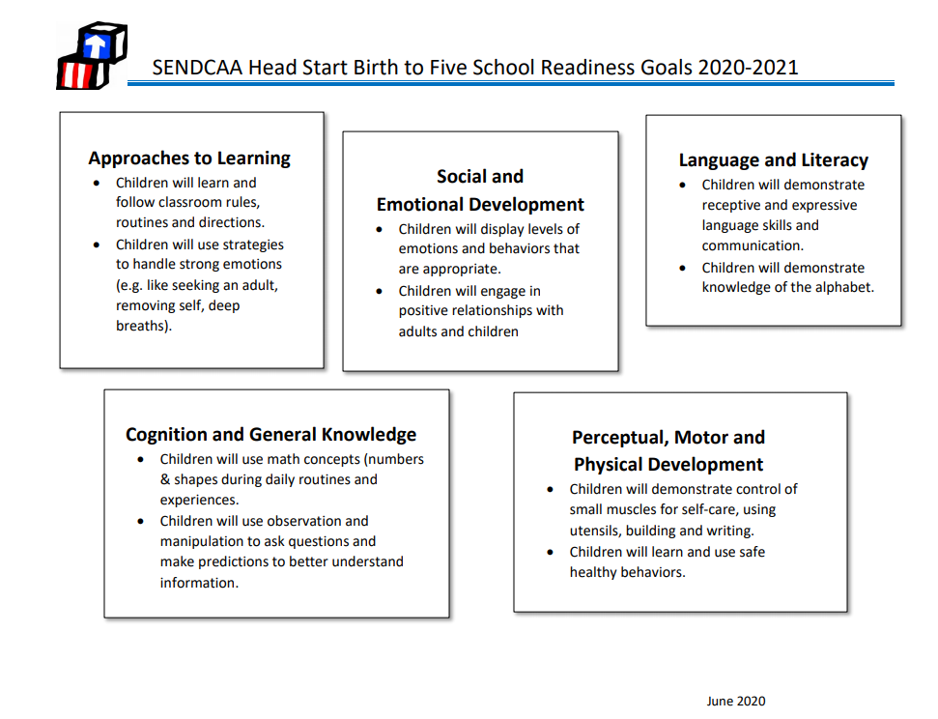

Our program collaborated with local school districts and built very strong partnerships with schools that receive children transitioning from Head Start. Kindergarten teachers, principals, SENDCAA Head Start teachers, and parents collaborate on determining our program School Readiness Goals. Also, all stakeholders are involved in the Kindergarten Transition Procedure. Our program sought feedback from local kindergarten teachers to determine what they felt was the most relevant child information when children from Head Start were entering into their classrooms. As a team, we created a kindergarten transition form that was sent to receiving schools, with parental consent, schools have found the forms extremely helpful in easing the transition for the children.
Our program also utilized the curriculum study, “Getting Ready for Kindergarten” to prepare children for what to expect in kindergarten.
Throughout the 2019-2020 year, teachers worked hard to prepare children and families for kindergarten. Overall, teachers continually educated on the importance of regular attendance, teachers collaborated with parents on ISRG, discussed child assessment data, and worked hard to provide ongoing opportunities on social-emotional skills to each and every child.
Highlights To Share
We always like to highlight the work with do with our community partners. Some of our classrooms were able to partake in Red River Dance Academy dance classes. We also were able to enjoy monthly visits from the Fargo & West Fargo Library. Our children were lucky enough to also receive a visit from FM Safekids & learned about medication safety.
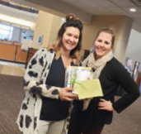
Another highlight to share was the work our Conscious Discipline Action Team (CDAT) did throughout the 2019-2020 year. This team met monthly to bring concepts of Conscious Discipline into our classrooms, sites, and entire program. The year was filled with ways to work together as a School Family and to give back to our community. We organized volunteer events at our Great Plains Food Bank & we spent time volunteering at our local homeless shelter, Churches United. During October, National Head Start Awareness Month, we completed a book drive with staff to raise money to purchase books for local organizations who serve children & families. In total, our staff raised $288.00. From there, we donated books to Rape & Abuse Crisis Center, The Children’s Advocacy Center, YWCA, Cass County Social Services, WIC, and many more wonderful organizations.
In the spring of 2020, all program staff completed a book study with the book, The Energy Bus. Our staff engaged in reading this book together and reflected on how to bring the concepts from the reading to their work & personal lives. Overall, this brought our School Family together which resulted in a stronger, more positive work culture.

COVID-19 Pandemic Response
The spring of 2020 brought a world of unknowns to us all. While our doors temporary closed, our services never ceased. When we no longer had classes’ in-person, we provided weekly academic packets individualized for the children in our program. Classroom teachers spent time engaging with children over Seesaw on a regular basis.
Classroom teachers called families each week to check-in to see how they child and family were doing. We regularly shared community-wide resources with our families and found additional resources and supports as needed.
Fortunately, our program was able to partner with #GiveTogetherNow. This was a rapid-response emergency cash assistance fund launched for the express purpose of getting cash into the hands of eligible households identified by nonprofit partners who had been hurt by steps taken to contain COVID-19 – business, school and daycare closers as well as quarantine mandates. We were able to connect 88 families with the $500 one-time payment.
Our program Health Coordinators/Family Support Staff continued to stay connected with the families throughout by checking in with them and providing weekly nutrition/health information. In addition, staff at various site locations assisted with food bag pick up, deliveries to homes, and diaper & formula deliveries to families, as needed.
As we continued to navigate our way through the pandemic our program created a COVID-19 Response Plan and reopened our doors on June 15th, 2020 to our Early Head Start children and families. Our Response Plan evolved throughout the pandemic and continues to change. The Response Plan focused on PPE, cleaning procedures, staff/child ratios, pick-up/drop-off routines, etc. As the year continued on, we provided ongoing modification to the response plan as our community and program continued to adapt to the ongoing pandemic. Safety was our first priority to children, staff, and families served.
COVID resulted in our continued dedication to providing both social-emotional and developmental screens within 45 days of entry, in a modified capacity. The mental health and disabilities coordinator sent home the Ages and Stages Questionnaire: Social-Emotional for parents to complete, birth to five, for children who entered the program during distance learning. The Ages and Stage Questionnaire 3, which is the developmental screen that our Early Head Start teachers typically complete, was sent home to capture parent-report responses. For our 3-5 year olds, the coordinator modified the Brigance, using available clip art to provide visual aids, so that parents could offer their impressions of children’s development in the various areas typically screened by the standardized Brigance screening tool. A handout was also created that discussed stress in early childhood and provided information about children’s mental health resources that are available in the community.
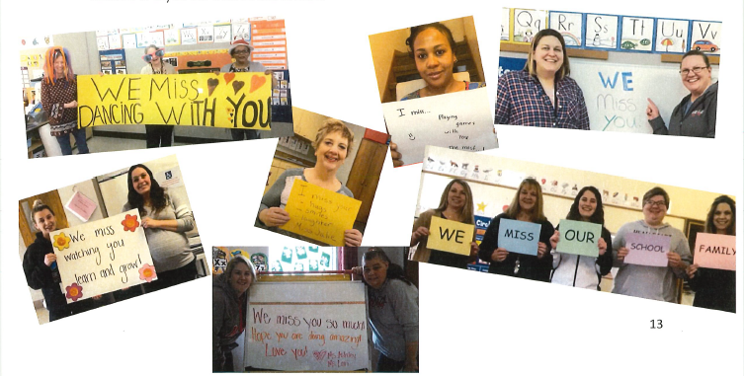
Although the COVID-19 pandemic hit us hard, we stood strong and were proud of the work we did (and continue to do) for our children and families.

